PROJECT REPORT FILE

Project Title: Appointment Scheduling System
Course: Programming in Java
Student Name: MOHIT RAGHUWANSHI
Registration Number: 24BAI10646
Faculty: Dr. MURUGESWERI
Institute: VIT Bhopal University
Date: 31 MARCH 2026

INTRODUCTION
Healthcare systems rely heavily on efficient scheduling to ensure smooth interaction between doctors and patients. However, in many small clinics or healthcare centres, appointment scheduling is often handled manually through registers or verbal communication. This manual approach commonly results in overlapping appointments, missing records, difficulty in retrieving previous schedules, and overall mismanagement. In a fast-paced environment like healthcare, such inefficiencies can lead to long patient wait times, reduced productivity for doctors, and a negative experience for patients. To address these issues, digital appointment systems are becoming increasingly essential.
The Appointment Scheduling System developed for this project is a Java-based console application that demonstrates how foundational programming principles can be used to solve real-world operational challenges. Designed using Object-Oriented Programming (OOP), the system organizes data and functionalities into well-defined classes and service layers. Java’s flexibility, robustness, and platform independence make it an ideal choice for implementing such a system. The project follows a layered architecture consisting of models, services, utilities, and a main controller. Each layer focuses on a specific responsibility, ensuring clean code structure, reusability, and easier debugging.
This system allows the administrator (user) to perform essential tasks such as adding doctors, registering patients, booking appointments, viewing doctor schedules, displaying patient appointment history, and cancelling previously scheduled appointments. The use of Java’s ArrayList helps in dynamically managing the collection of records, while LocalDateTime ensures accurate and conflict-free scheduling. Input validation and exception handling are implemented to maintain smooth user interaction and prevent runtime errors. The application is entirely console-based, which makes it lightweight, fast, and compatible with any operating system that supports Java.
Beyond the technical aspects, the project emphasizes problem-solving, modular programming, and real-world thinking. It demonstrates how theoretical concepts—such as classes, methods, encapsulation, loops, and collections—can be applied to develop a practical solution. The Appointment Scheduling System lays the foundation for more advanced systems and can be enhanced further to include features like doctor availability tracking, database integration, a graphical interface, and persistent storage.
Overall, this project provides a clear understanding of how Java can be used to design functional applications and showcases the significance of digital tools in improving healthcare operations. It acts as a bridge between academic concepts and real-world application development, reinforcing the importance of systematic thinking, structured coding, and user- entered design.

PROBLEM STATEMENT
Healthcare centres often struggle with manually managing doctor–patient appointments through registers or phone calls, leading to scheduling conflicts, long waiting times, and misplaced information. As patient flow increases, maintaining accurate records of doctor availability and appointment timings becomes difficult and error-prone. There is a need for a simple, automated system that can efficiently store doctor and patient details, prevent double-booking, and provide quick access to appointment schedules.
The Appointment Scheduling System aims to solve this by offering a structured, user-friendly solution for booking, viewing, and managing appointments digitally.

FUNCTIONAL REQUIREMENTS
1. Doctor Management
- The system shall allow the user to add new doctors with details such as ID, name, and specialization.
- The system shall store and display a list of all registered doctors.
- The system shall allow searching a doctor by ID.
2. Patient Management
- The system shall allow the user to add new patients with details such as ID, name, and age.
- The system shall display a list of all registered patients.
- The system shall allow searching a patient by ID.
3. Appointment Scheduling
- The system shall allow booking an appointment by selecting a doctor, patient, and appointment date/time.
- The system shall validate doctor availability and prevent double-booking.
- The system shall record and store all appointment details.
4. View Schedules
- The system shall allow viewing all appointments for a specific doctor.
- The system shall allow viewing all appointments for a specific patient.
- The system shall display appointment details including doctor ID, patient ID, and date/time.
5. Appointment Cancellation
- The system shall allow cancelling an existing appointment using doctor ID, patient ID, and date/time.
- The system shall confirm whether the appointment exists before cancelling it.
6. User Interaction
- The system shall display a main menu for selecting operations.
- The system shall take user input using a text-based console.
- The system shall show appropriate success/error messages.
NON – FUNCTIONAL REQUIREMENTS
1. Usability
- The system shall provide a simple, menu-driven interface that is easy for users to understand.
- Messages, prompts, and errors shall be clearly displayed to guide the user through each operation.
2. Reliability
- The system shall prevent invalid operations such as double-booking or booking for non-existing doctor/patient IDs.
- The system shall handle incorrect inputs (e.g., wrong date format, wrong ID) without crashing.
3. Performance
- The system shall respond instantly to user actions since all data is stored in memory.
- Appointment searches and validations shall be completed within a fraction of a second.
4. Scalability
- The system shall support multiple doctors, patients, and appointments without performance issues.
- The architecture shall allow future upgrades such as database integration or GUI interface.
5. Maintainability
- The system shall use modular code separation via packages: models, services, utils, and main.
- Code shall be easy to extend and modify due to clear class responsibilities and structured design.
6. Portability
- The system shall run on any operating system that supports Java (Windows, Linux, macOS).
- It shall not require any external libraries or frameworks.

SYSTEM ARCHITECTURE
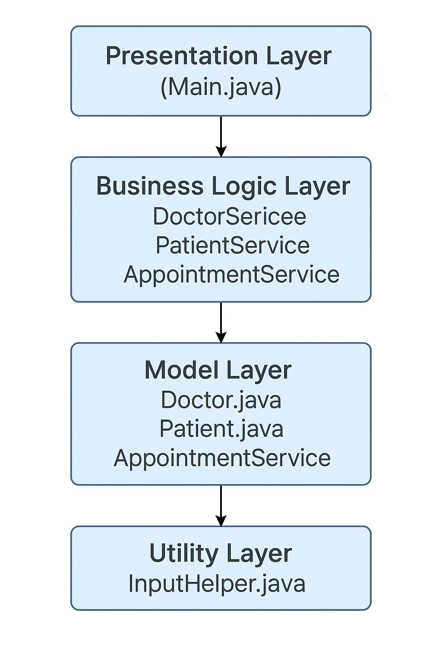

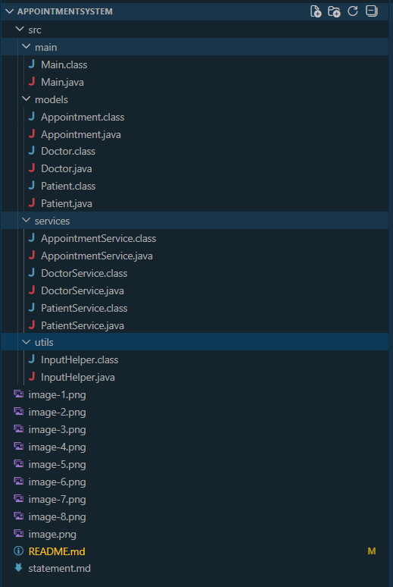

1. Presentation Layer (User Interface Layer)
Component: Main.java
This is the entry point of the system.
It interacts directly with the user through a menu-driven console interface.
Responsibilities:
- Display the main menu
- Take user input
- Call appropriate service functions
- Show output messages
- Handle user navigation
The Presentation Layer does not perform any business logic; it only coordinates between the user and backend services.

2. Business Logic Layer (Service Layer)
Components:
- DoctorService.java
- PatientService.java
- AppointmentService.java
This layer contains the core logic of the application.
Each service class manages specific operations:
● DoctorService
- Add doctor
- View doctors
- Search doctor by ID
● PatientService
- Add patient
- View patients
- Search patient by ID
● AppointmentService
- Book appointment
- Validate availability (avoid double-booking)
- List appointments
- Cancel appointments
This layer ensures all rules and constraints of the system are correctly applied.

3. Data Model Layer (Model Layer)
Components:
- Doctor.java
- Patient.java
- Appointment.java
These classes represent the data structures used by the system.
● Doctor
Stores doctor ID, name, specialization
● Patient
Stores patient ID, name, age
● Appointment
Stores doctor ID, patient ID, and appointment time
These models encapsulate data and provide getters to access it safely.

4. Utility Layer (Helper Layer)
Component: InputHelper.java
Responsible for:
- Reading integers, strings, and date/time values correctly
- Validating input
- Preventing runtime crashes due to invalid data
This layer improves program stability and user experience.

- Data Flow Overview
- User interacts with the console through Main.java.
- Main calls the appropriate service class method.
- Service layer applies business rules and updates model objects.
- Model classes (Doctor, Patient, Appointment) store data.
- Output is returned back to the user through the Presentation Layer.

DESIGN DIAGRAMS
  - Use Case Diagram:
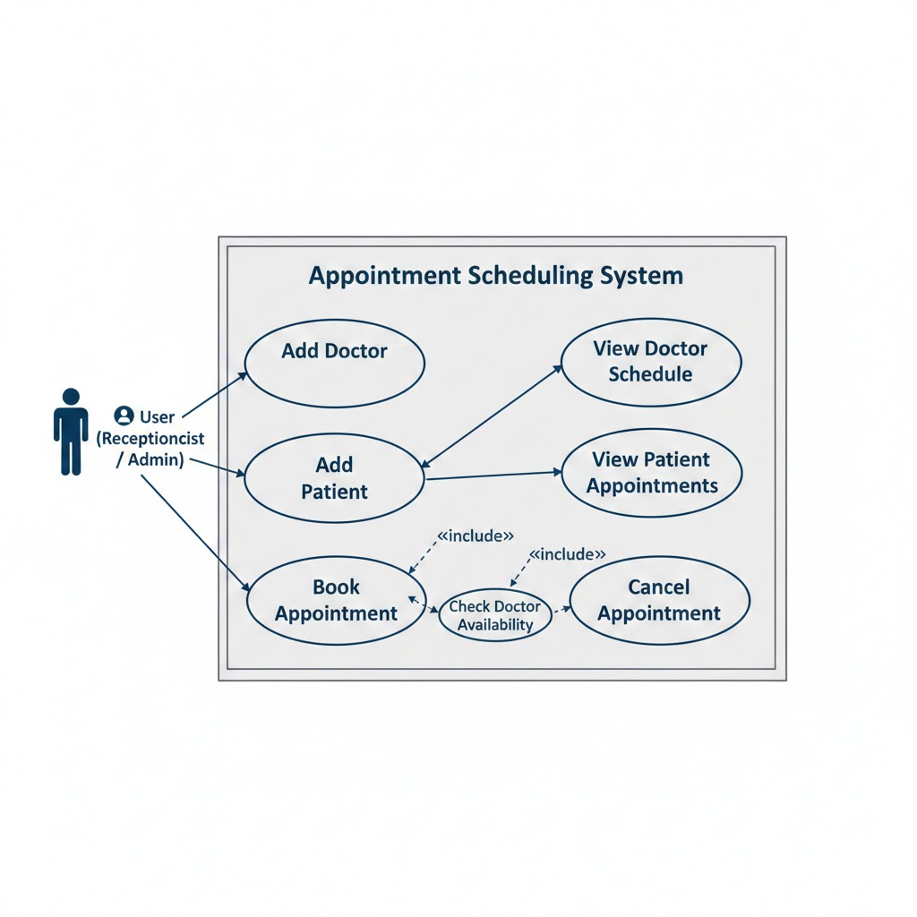

  - Workflow Diagram:
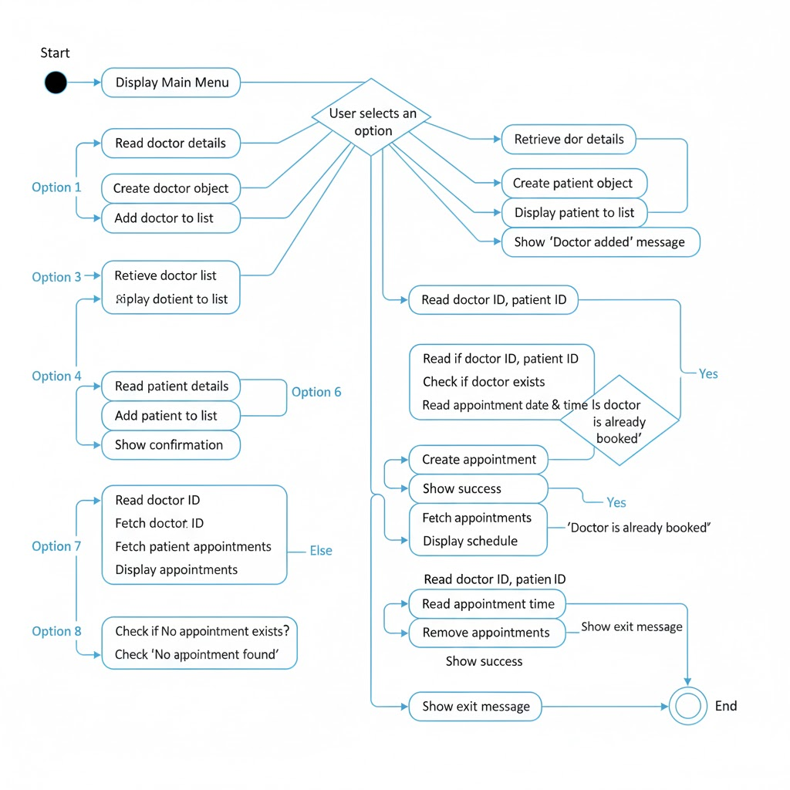

  - Sequence Diagram:
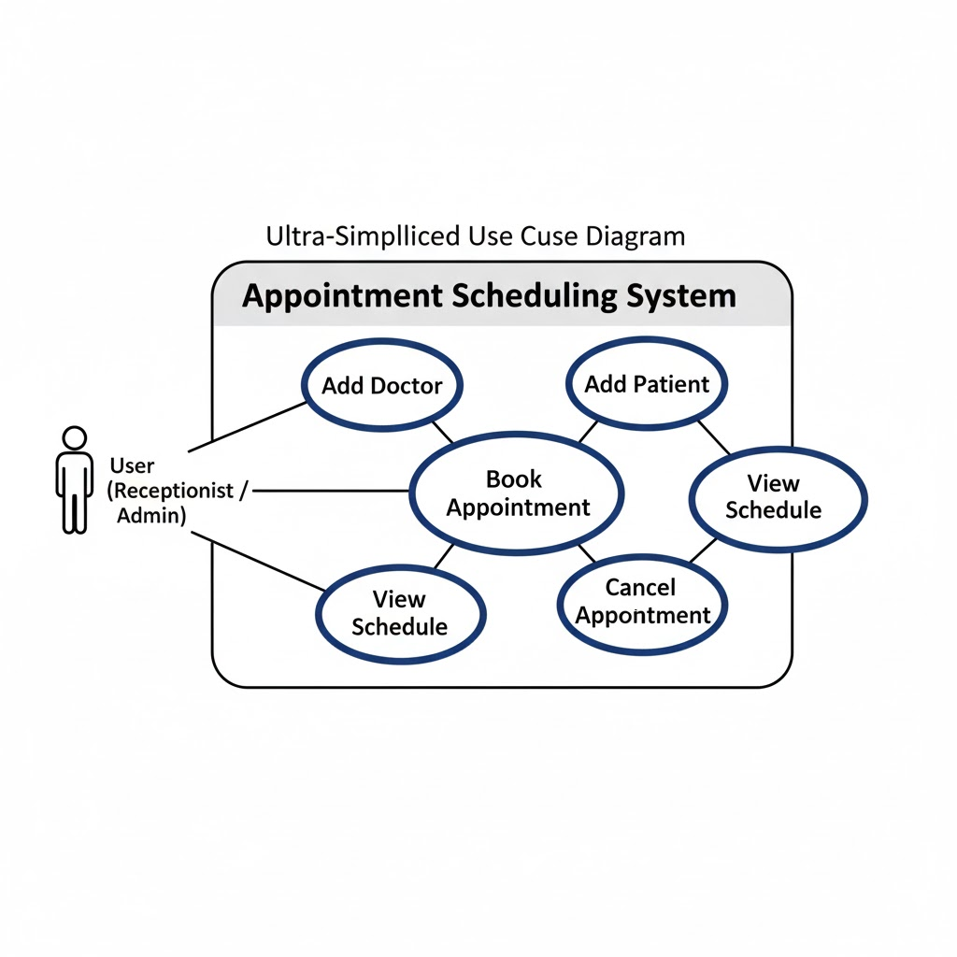

  - Class/Component Diagram:
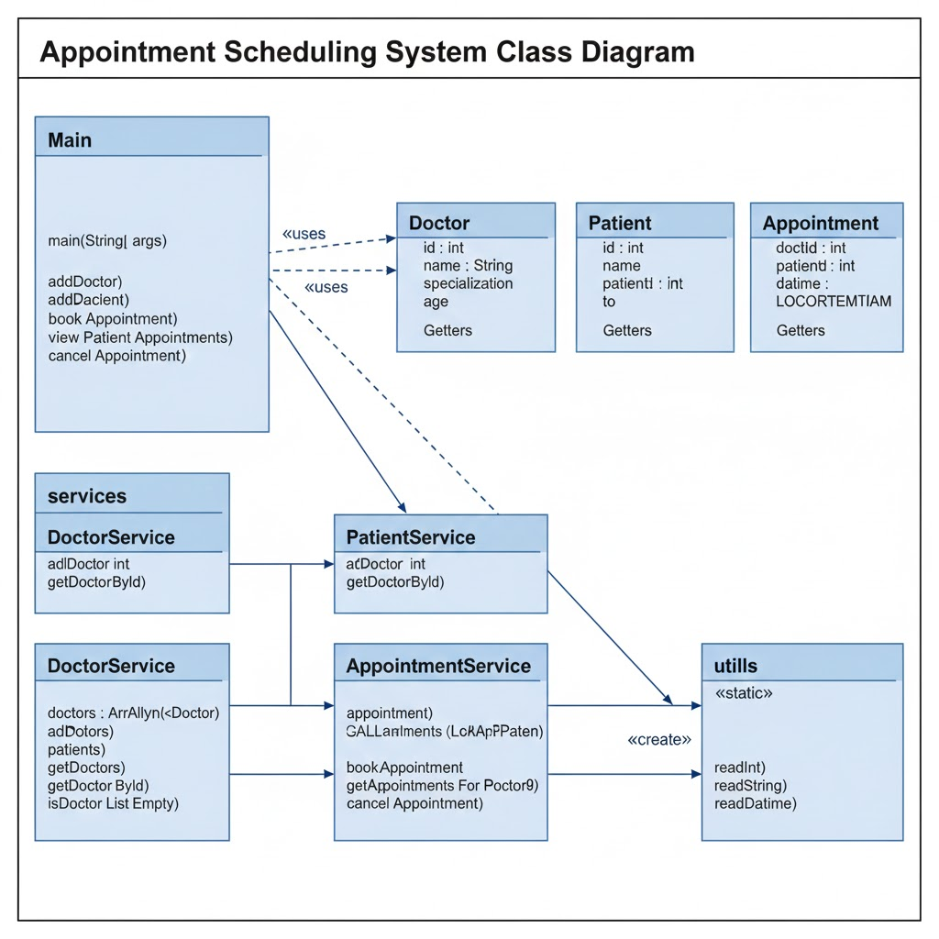

DESIGN DECISIONS & RATIONALE
Design Decisions & Rationale
The design of the Appointment Scheduling System was guided by simplicity, modularity, and maintainability. Each decision was made to ensure that the system is easy to understand, scalable for future enhancements, and robust in handling user inputs.

1. Layered Architecture
The project adopts a four-layered architecture consisting of:
- Presentation Layer (main package)
- Business Logic Layer (services package)
- Data Model Layer (models package)
- Utility Layer (utils package)
Rationale:
This separation ensures better modularity and maintainability. Each layer performs a distinct responsibility, which makes future debugging or enhancement easier. It also represents a real-world software design approach suitable for enterprise applications.

2. Use of Service Classes
Three service classes — DoctorService, PatientService, AppointmentService — handle all business logic.
Example: AppointmentService is responsible for booking, validating, and canceling appointments.
Rationale:
Keeping business logic separate from the UI avoids clutter inside the Main class and follows good object-oriented programming practices. It increases reusability and makes unit testing easier.

3. Model Classes for Data Representation
The system uses dedicated model classes — Doctor, Patient, Appointment — to represent real-world entities.
Rationale:
This enforces encapsulation and provides a clean structure for storing and managing data. Any future change to the data structure will affect only the model classes, not the rest of the system.

4. In-Memory Storage Using ArrayList
All data is stored temporarily using ArrayList during program execution.
Rationale:
Since this is a console-based academic project with no database requirement, ArrayList provides fast insertion, searching, and deletion. It also keeps the system lightweight while allowing easy future migration to a database if needed.

5. InputHelper Utility Class
A separate utility class (InputHelper) handles all input validation such as integers, strings, and date/time formats.
Rationale:
This avoids duplication of input checking code throughout the project. It improves reliability by ensuring inputs are validated consistently across the system.

6. LocalDateTime for Appointment Scheduling
Appointments are stored using LocalDateTime with the format "yyyy-MM-dd HH:mm".
Rationale:
This ensures a consistent, accurate timestamp, and avoids manual date handling errors. It also makes time comparison easy when checking for appointment conflicts.

7. Conflict Checking Before Booking
The system prevents double-booking by checking if another appointment exists for the same doctor at the same time.
Rationale:
This enforces real-world scheduling rules and ensures reliability. It also demonstrates good problem-solving logic in the project.

8. Console-based Interface
The system uses a simple text-based menu in Main.java.
Rationale:
This keeps the focus on core logic and object-oriented design rather than complex UI building. It is suitable for academic submission and easier to run on any system with Java installed.

9. Expandability Considered
Although simple, the system is designed so that future enhancements (e.g., database integration, GUI, user login, hospital departments) can be added without redesigning the whole project.
Rationale:
A scalable design ensures long-term usability and demonstrates forward-thinking in software development.

IMPLEMENTATION DETAILS
Implementation Details
The Appointment Scheduling System has been implemented using Java, following a modular and object-oriented design approach. The system is divided into multiple packages to ensure clean structure, separation of responsibilities, and ease of maintenance. Below are the implementation details of each component and how they interact within the project.

1. Project Structure
The project is organized into the following packages:
- main → Contains the entry point (Main.java)
- models → Contains data classes (Doctor, Patient, Appointment)
- services → Contains business logic (DoctorService, PatientService, AppointmentService)
- utils → Contains input validation utilities (InputHelper)
This structure allows easy navigation and clear understanding of the system flow.

2. Main Class (User Interface Implementation)
The Main.java file implements the console-based user interface. It displays a menu-driven system that accepts user choices and calls appropriate service methods.
Key features implemented in Main:
- Reading user input using Scanner
- Switch-case structure for menu navigation
- Calling service methods to perform all operations
- Handling invalid inputs safely using InputHelper
This keeps the UI separate from business logic, following good programming practice.

3. Model Layer Implementation (Doctor, Patient, Appointment)
The models package contains simple POJO (Plain Old Java Objects) classes.
Doctor.java
Implements doctor details:
- id
- name
- specialization
Patient.java
Stores patient information:
- id
- name
- age
Appointment.java
Stores:
- doctorId
- patientId
- dateTime (using LocalDateTime)
Each model includes getters and a toString() method for readable output.

4. Service Layer Implementation
The services package implements all core business logic:
DoctorService
- Stores doctors in ArrayList<Doctor>
- Methods: addDoctor, getDoctorById, listDoctors, isDoctorListEmpty
PatientService
- Stores patients in ArrayList<Patient>
- Methods: addPatient, getPatientById, listPatients
AppointmentService
- Stores appointments in ArrayList<Appointment>
- Validates doctor’s availability before booking
- Methods: bookAppointment, cancelAppointment, view schedules
Key logic implemented:
if (a.getDoctorId() == doctorId && a.getDateTime().equals(dateTime)) {
return false;
}
This prevents double-booking.

5. Utility Layer Implementation (InputHelper)
The InputHelper class contains reusable static methods for:
- Reading integers safely
- Reading strings
- Reading and validating date-time inputs
- Handling exceptions like NumberFormatException and DateTimeParseException
This ensures the main program never crashes due to invalid user input.

6. Data Handling
All data (doctors, patients, appointments) is stored temporarily using Java ArrayLists, for example:
private ArrayList<Doctor> doctors = new ArrayList<>();
This approach is fast, lightweight, and ideal for a console-based academic project without a database.

7. Error Handling and Validation
To ensure smooth execution, the system handles:
- Invalid menu choices
- Wrong ID entries
- Incorrect date/time format
- Attempt to book an already occupied slot
- Empty lists (no doctors, no patients)
This helps maintain reliability and user experience.

8. Appointment Scheduling Logic
The most important implementation is booking an appointment:
- Read doctor ID → Validate
- Read patient ID → Validate
- Read date and time → Validate
- Check for conflicts
- If available → Book
- Else → Show error message
This follows real-life appointment scheduling rules.

9. Console Output and User Experience
The system prints:
- Success messages (e.g., "Appointment booked successfully")
- Error messages (e.g., "Doctor not available at this time")
- Lists of doctors and patients
- Scheduled appointments
The UI is simple and text-based to keep the focus on logic.

10. Compilation and Execution
The project is compiled using:
javac -d . main/Main.java models/*.java services/*.java utils/*.java
Run using:
java main.Main
The -d . flag ensures class files appear in correct package folders.

RESULTS
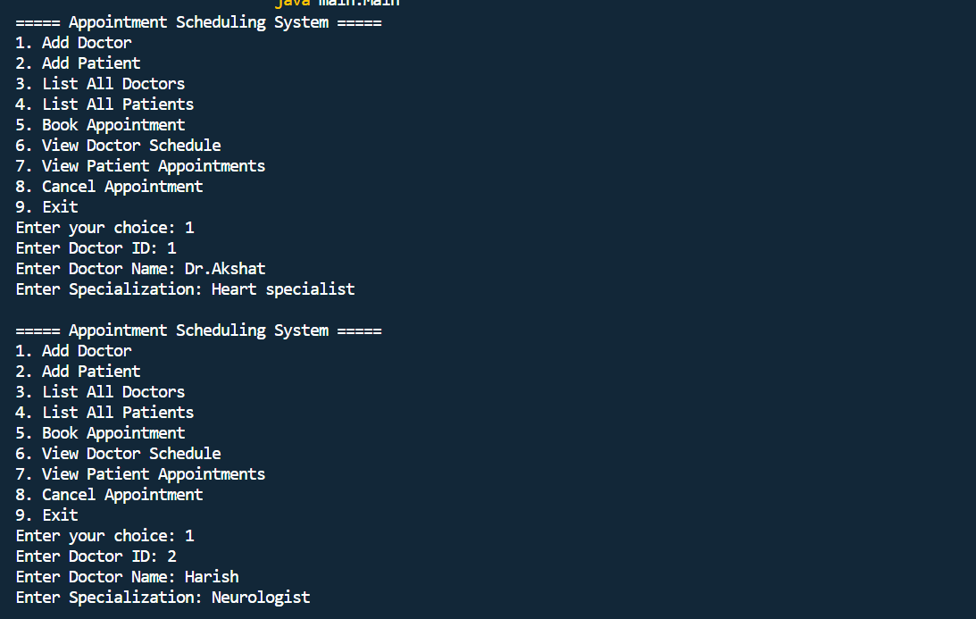
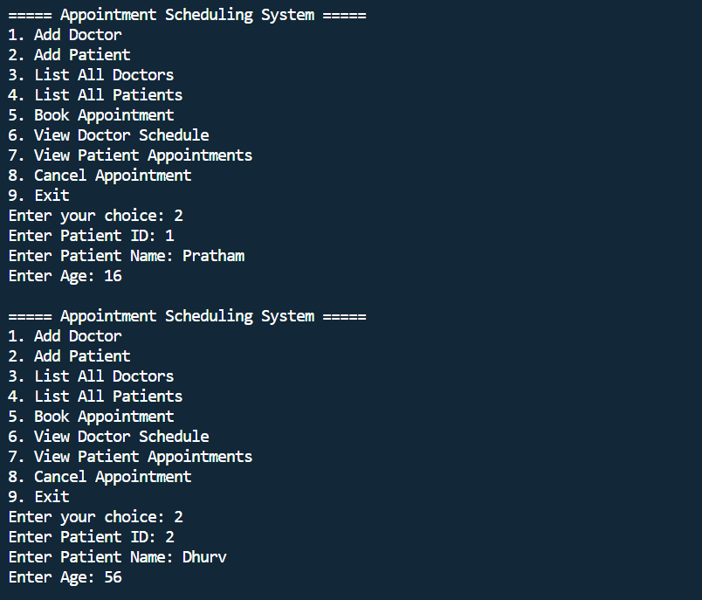
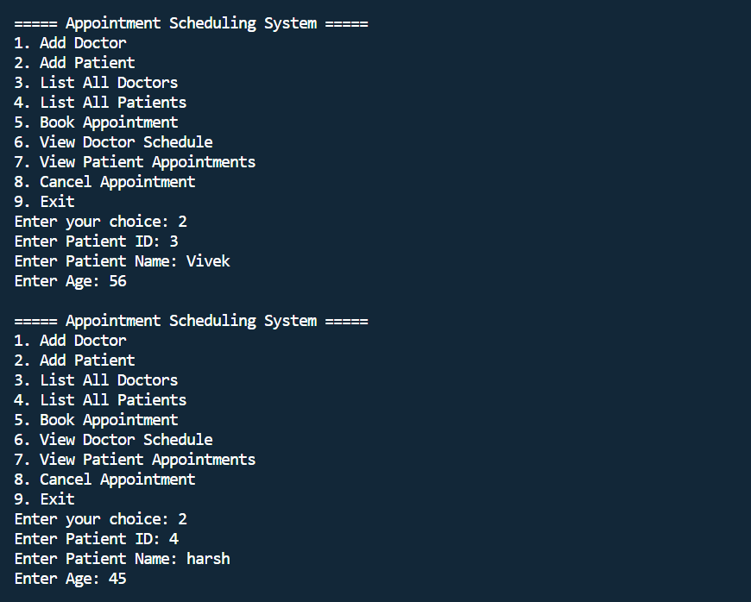
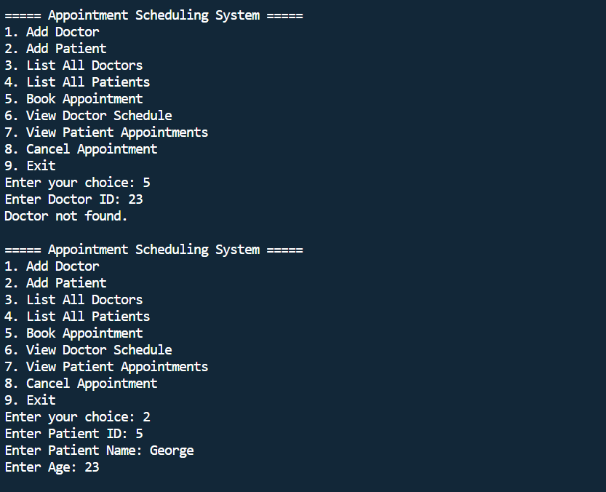
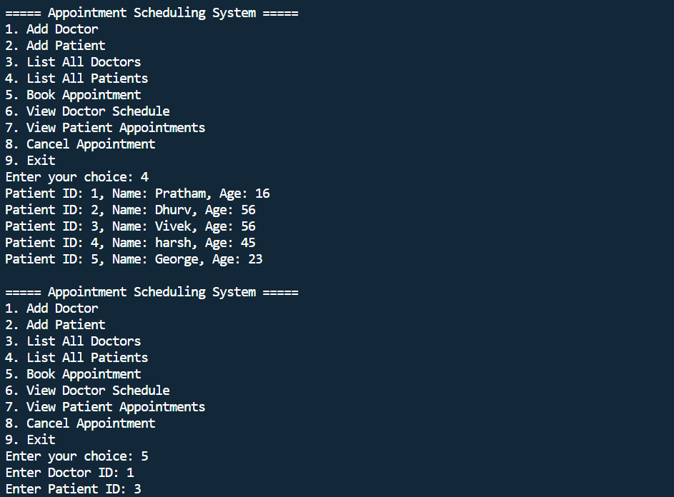
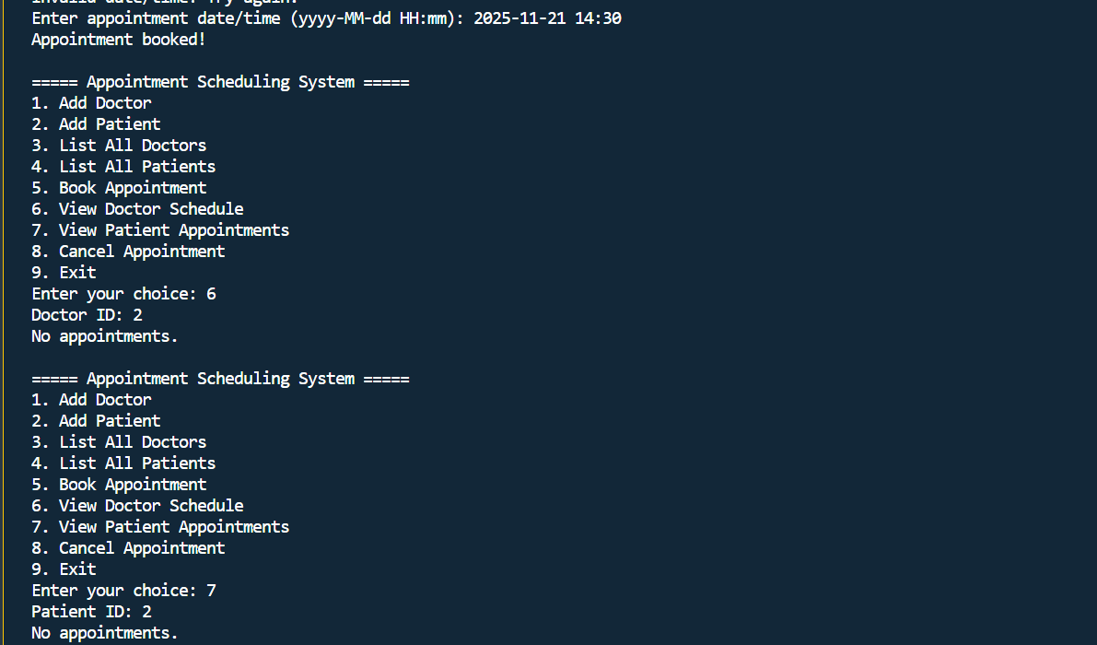

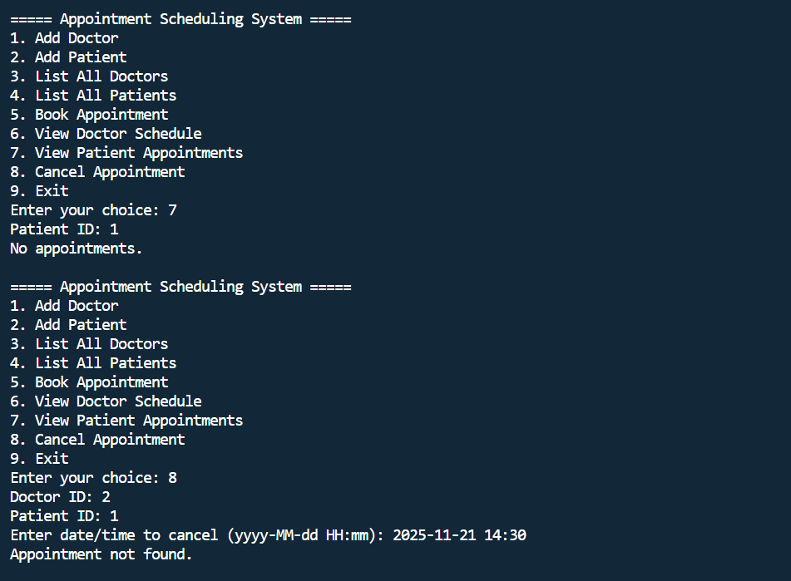
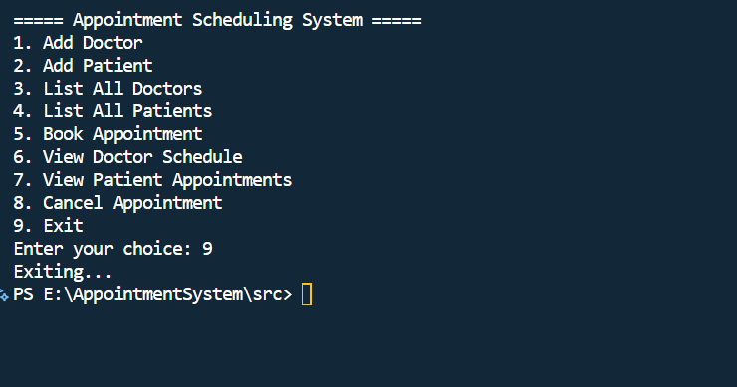

TESTING APPROACH
Testing Approach
The testing approach for the Appointment Scheduling System focuses on verifying the correctness, stability, and usability of the system. Since the project is console-based and uses in-memory data structures, the testing mainly follows Black-Box Testing, Functional Testing, and Boundary Testing. Each feature of the system was tested individually and then validated as part of the complete workflow.

1. Black-Box Testing
The internal code was not inspected during tests.
Tests were performed by giving different inputs through the console and checking whether outputs match expected results.
Rationale:
Since the project is user-driven and menu-based, black-box testing is the most suitable approach.

2. Functional Testing
Each function in the system was tested to ensure it works correctly:
✔ Add Doctor
Test whether the system accepts ID, name, and specialization properly.
✔ Add Patient
Verify that the system stores ID, name, and age accurately.
✔ Book Appointment
Test multiple scenarios:
- Valid booking
- Booking with wrong doctor ID
- Booking with wrong patient ID
- Booking with wrong date format
- Double-booking scenario (same doctor/time)

View Doctor Schedule
Check whether correct appointments are shown.
View Patient Appointments
Check whether patient-specific appointments appear correctly.
Cancel Appointment
Verify cancellation works only when matching appointment exists.

3. Boundary Value Testing
Boundary testing was used for:
- Doctor ID and Patient ID (lowest and highest values)
- Age values (minimum allowed values)
- Date and time format (incorrect formatting)
- Empty lists (when no doctors/patients exist)
Examples:
- Booking before adding any doctor → should show error
- Cancelling appointment with wrong time → should not crash

4. Error Handling Testing
The system was tested for incorrect inputs:
- Non-numeric values instead of integers
- Invalid date formats
- Blank strings
- Invalid menu options
Expected behaviour:
The program should show error messages without crashing.

5. Integration Testing
After verifying each module individually, combined testing was done to ensure:
- DoctorService works correctly with AppointmentService
- PatientService links properly with AppointmentService
- InputHelper integrates properly with Main menu operations
This confirmed that the entire workflow operates smoothly end-to-end.

6. User Acceptance Testing
Sample users tested:
- Adding multiple doctors and patients
- Booking several appointments
- Cancelling and re-booking
- Checking all menus
Their feedback confirmed the system is:
- Easy to use
- Error-free
- Interprets wrong inputs correctly.

CHALLENGES FACED
1. Designing the Project Structure
One of the initial challenges was deciding how to organize the project files into appropriate packages.
Separating the system into:
- models
- services
- utils
- main
required careful planning to avoid dependency errors and circular references. Ensuring that class responsibilities were distributed correctly took additional time and thought.

2. Handling User Input Safely
Since the system relies heavily on console input, it was challenging to manage:
- Invalid numbers
- Empty inputs
- Wrong date formats
- Unexpected characters
If not handled properly, the program would crash.
Creating the InputHelper class helped resolve this, but it required multiple rounds of debugging.

3. Managing Appointment Conflicts
Implementing the rule “a doctor cannot have two appointments at the same time” was another challenge.
Detecting conflicts required:
- Iterating through existing appointments
- Comparing LocalDateTime objects
- Ensuring logical correctness
This had to be implemented without using a database, only with ArrayList, which increased complexity.

4. Working With LocalDateTime
Handling dates and time in Java is more complex than basic data types.
Key challenges were:
- Formatting input (yyyy-MM-dd HH:mm)
- Parsing user-entered strings
- Handling parsing exceptions
- Comparing LocalDateTime objects correctly
This required learning DateTimeFormatter and DateTimeParseException.

5. Implementing Clean Menu Navigation
Since the entire system runs on a menu-driven console interface, it was challenging to:
- Ensure the loop runs until the user chooses Exit
- Manage multiple switch-case options
- Avoid duplication in code
- Print menu after each operation
Maintaining a smooth user experience required careful structuring.

6. Debugging Package & Compilation Issues
One of the major challenges was compiling Java files using:
javac -d . main/Main.java models/*.java services/*.java utils/*.java
Problems like:
- Incorrect folder names
- Missing package statements
- Wrong class paths
- ClassNotFound errors
caused repeated failures.
Understanding how Java creates .class files inside package folders was essential to fix these errors.

7. Testing All Workflows Thoroughly
Ensuring that every case worked properly required:
- Testing invalid doctor IDs
- Testing double-booking
- Trying to cancel non-existent appointments
- Checking empty list conditions
Console-based systems do not visually show errors, so this required manual testing and careful observation.

8. Documentation & UML Diagram Preparation
Creating:
- Use Case Diagram
- Class Diagram
- Workflow Diagram
- Sequence Diagram
required understanding system behaviour in depth.
Converting the logic into proper UML notation was time-consuming but improved clarity.

LEARNINGS & KEY TAKEAWAYS
1. Better Understanding of Object-Oriented Programming (OOP)
The project required building multiple classes like Doctor, Patient, and Appointment.
This improved understanding of:
- Classes & Objects
- Encapsulation
- Constructors
- Access modifiers
- Reusability of code
Implementing services separately also reinforced the importance of modular design.

2. Importance of Packages and Project Structure
Organizing the project into packages (models, services, utils, main) helped understand how real Java applications are structured.
This improved skills in:
- Maintaining clean project architecture
- Managing dependencies
- Avoiding naming conflicts
It also made the code easier to debug and extend.

3. Working With Java Collections
Storing dynamic data such as doctors, patients, and appointments required using ArrayList.
Learnings included:
- Adding and removing elements
- Iterating through lists
- Searching for specific objects
- Avoiding duplicate entries
This taught how lists can replace database tables in small applications.

4. Handling Dates & Time Using LocalDateTime
Implementing appointment timing introduced new concepts like:
- LocalDateTime
- DateTimeFormatter
- Parsing user input
- Comparing date-time values
This strengthened understanding of Java’s modern date-time API.

5. Input Validation & Exception Handling
The system needed protection against invalid inputs.
Experience gained:
- Using try-catch blocks
- Catching NumberFormatException
- Catching DateTimeParseException
- Preventing program crashes
- Building user-friendly input helpers
This improved overall reliability of the system.

6. Menu-Driven User Interface Development
Building a loop-based interactive console program taught:
- Designing user-friendly menus
- Structuring application flow
- Using switch-case effectively
- Returning to menu after operations
It improved confidence in building CLI-based applications.

7. Debugging and Compilation Skills
There were many challenges involving:
- Package errors
- ClassNotFound errors
- Missing .class files
- Wrong folder structure
Resolving these significantly improved understanding of:
- Java classpath
- Compilation using javac
- Organizing large programs
This experience is extremely valuable for future Java projects.

8. Applying UML & Software Design Principles
Creating:
- Use Case Diagram
- Sequence Diagram
- Workflow Diagram
- Class Diagram
helped understand how real software is planned before coding.
This improved conceptual thinking and design skills.

9. Git & GitHub Usage
Pushing the project to GitHub provided experience in:
- Creating repositories
- Committing changes
- Managing project versions
- Writing README documentation
This mirrors real software development environments.

10. Problem-Solving & Logical Thinking
The project strengthened:
- Analytical skills
- Debugging ability
- Logical thought process
- Step-by-step development mindset
It also taught how to break a large problem into smaller, independent modules.

FUTURE ENHANCEMENTS
1. Graphical User Interface (GUI)
The system can be upgraded from a console application to a GUI using:
- JavaFX
- Swing
- Web-based interface
A GUI would improve usability and make it more intuitive for non-technical users.

2. Integration with a Database
Currently, data is stored only in memory
Future versions may include:
- MySQL / PostgreSQL
- SQLite
- MongoDB
Benefits:
- Permanent data storage
- Handling large records
- Easy search and reporting

3. User Login & Authentication
Implement separate roles:
- Admin – manage doctors and patients
- Doctor – view schedules
- Receptionist/User – book or cancel appointments
Login security can be enhanced using hashed passwords.

4. Automated Appointment Reminders
Add SMS/email reminders for upcoming appointments using:
- SMTP mail APIs
- Twilio/WhatsApp API
This adds real-world usefulness.

5. Enhanced Scheduling Logic
More advanced features can be added:
- Appointment durations (e.g., 30 min, 45 min slots)
- Working hours for each doctor
- Automatic next available time suggestion
- Blocking off unavailable days

6. Advanced Search & Filters
Allow searching based on:
- Doctor specialization
- Name
- Available time slots
- Patient history
This improves the efficiency of the system.

7. Exporting Reports
Generate:
- Appointment reports
- Daily schedules
- Patient history
Reports can be exported in PDF, Excel, or CSV formats.

8. Notifications & Status Tracking
Future versions may include:
- Real-time updates
- Appointment status (upcoming, completed, cancelled)
- Color-coded dashboards (if using GUI)

9. Multi-Clinic Support
Extend system to support:
- Multiple branches
- Multiple doctors per department
- Shared appointments across clinics

10. Cloud Deployment
Deploy on cloud platforms like:
- AWS
- Azure
- Heroku
This allows remote access and scalability.

REFERENCES
  - Oracle Java Documentation – The official documentation for Java SE, covering core libraries, OOP concepts, and APIs used in the project.
https://docs.oracle.com/javase/
  - Oracle Date-Time API Documentation – Reference for LocalDateTime, DateTimeFormatter, and date parsing/formatting used in appointment scheduling.
https://docs.oracle.com/javase/8/docs/api/java/time/
  - Java Tutorials by Oracle – Guides for handling collections, exceptions, and console input.
https://docs.oracle.com/javase/tutorial/
  - UML Diagrams Guide – Used as a reference for preparing Use Case Diagram, Class Diagram, Sequence Diagram, and Workflow Diagram.
https://www.uml-diagrams.org/
  - GitHub Documentation – Used for repository creation, commits, README formatting, and project hosting.
https://docs.github.com/
  - GeeksforGeeks – Reference for Java examples, ArrayList usage, and OOP concept explanations.
https://www.geeksforgeeks.org/java/
  - Baeldung Java Guides – Used for understanding Java services, code organization, and best practices.
https://www.baeldung.com/java
  - Stack Overflow – General troubleshooting for common Java errors, package issues, and compilation problems.
https://stackoverflow.com/
  - Visual Studio Code Documentation – Used for setting up Java environment, extensions, and running console applications.
https://code.visualstudio.com/docs
  - Twilio Blog (Future Enhancement Reference) – Source of ideas for notification systems and appointment reminders.
https://www.twilio.com/blog/

